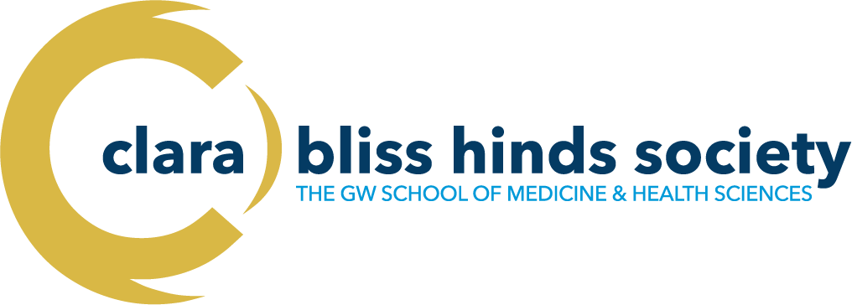
ANNUAL MENTORSHIP AWARDS (2023) Nomination Form

NOMINATOR INFORMATION: (Candidates may self-nominate)
First Name: | Last Name: | Title:
Email Address: | Phone #: | Department/Division:

NOMINEE INFORMATION: Please provide the information requested below regarding the mentor being nominated for the award
First Name: | Last Name: | Title:
Email Address: | Phone #: | Department/Division:
Which Best Describes the Nominee: Highlight only 1 choice

Rising Star: 2-10 years after completion of post graduate education (e.g., residency/fellowship, post-doc) | Shining Bright: 11-20 years after completion of post graduate education | Luminary: 21+ years after completion of post graduate education
NOMINATOR/MENTEE INFORMATION (continued)
Please provide the required information below regarding nomination letters. Letters from supervisors and/or Division/Department Chiefs are not required. Letters can be written by more than one mentee OR include supporting comments from multiple mentees. At least one letter from the mentee or mentees is strongly encouraged. Letters can be from individuals outside of GW SMHS and Children’s National. Letters should be addressed to the Executive Committee of the Clara Bliss Hinds Society.
Nomination Letter #1:
First Name: | Last Name: | Title:
Email Address: | Phone: | Department/Division:
Nomination Letter #2:
First Name: | Last Name: | Title:
Email Address: | Phone: | Department/Division:

Completed Nomination Packets Include:

- Completed nomination form
- CV of nominee with a list or table* of current and former mentees and their accomplishments, which could include professional development, scholarship, teaching, successful application to university/college, medical school, graduate school, residency, postgraduate training, scholarship, teaching, personal support and encouragement, among others. (15 pages maximum)
- 2 letters of nomination (1-2 pages max), addressed to the Executive Committee of the Clara Bliss Hinds Society
*See website for example mentoring grid to include in CV: https://clarablisshinds.smhs.gwu.edu/mentorship-awards

The completed Nomination Packet should be sent as a single pdf to clarabliss@gwu.edu with the subject line Mentorship Award – Nominee’s Full Name

Nomination packets emailed after the deadline will not be accepted.

